“Education Is the Key to Success” . . . Pensal J. McCray, ECCC Founder
ETHNIC COLLEGE COUNSELING CENTER (ECCC) INC.
2019 – 2020 MIDDLE AND HIGH SCHOOL COLLEGE PREPARATORY PROGRAM

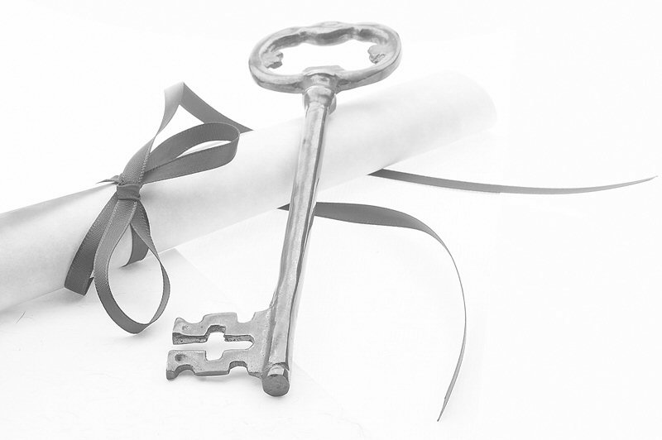
PARENTS: College is competitive and costly, and we all want your child(ren) to be accepted and to graduate. For over three decades the ECCC has conducted Education, Professional, Skills, and Cultural Workshops to help prepare Middle School and High School students
(6th - 12th graders) for education beyond high school.

We meet 9 – Noon, the first and third Saturdays, from September 21, 2019, to June 6, 2020 at:
Park Hill United Methodist Church
5209 Montview Blvd (Room 205), Denver, CO
(Enter from parking lot at NW corner of Montview & Glencoe St)

WORKSHOP TOPICS INCLUDE:
- Vocabulary building for improved standardized test scores
- Test Taking Tips for Middle and High School and College
- Essay Writing and Journaling
- Finding Financial Aid
- Library Research Skills
- Introducing Careers and Presentations of Panels of Professionals in Various Fields
- Goal Setting
- Building Confidence Through Public Speaking and Briefing Skills
- Summer Enrichment Program Application Assistance
- Life Skills – e.g. Social Media Advantages and Disadvantages; Handling Money, First Impressions in Language, Writing, and Dress; Surviving That Freshman Year
- HBCU College Tour 2019
- HBCU/HSI College Fair 2021
PARTICIPATION REQUIRES:
Attendance: no more than 3 unexcused absences;
Volunteer Assistance from Parents;
$100.00 Tuition
AUTHORIZATION FOR MY CHILD TO PARTICIPATE IN ECCC COLLEGE PREPARATORY WORKSHOPS

STUDENT NAME: ___________________________________________ AGE: _______ GRADE: _________

PARENT NAME: _________________________________________________________________________

ADDRESS:______________________________________________________________________________
TELEPHONE: ____________________________ EMAIL ADDRESS: _________________________________

I hereby also authorize the ECCC to use images of my child participating in ECCC activities.

PARENTAL SIGNATURE:___________________________________________________________________

